SubQueries

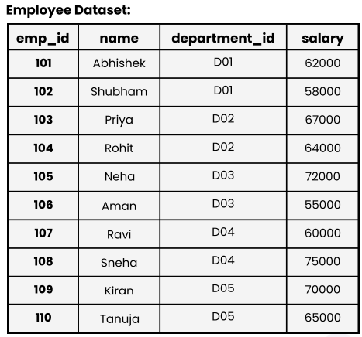
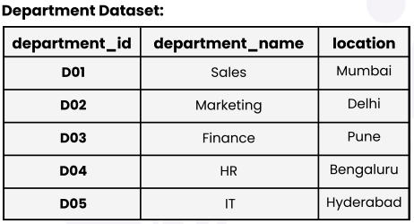
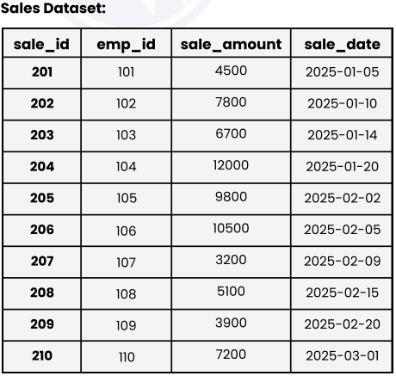
Solution : -
CREATE TABLE Department (department_id VARCHAR(3) , department_name VARCHAR(50), location VARCHAR(50));
CREATE TABLE Employee (emp_id INT , name VARCHAR(50), department_id CHAR(3),salary INT);
CREATE TABLE Sales (sale_id INT,emp_id INT,sale_amount INT,sale_date DATE);
INSERT INTO Employee (emp_id, name, department_id, salary) VALUES (101, 'Abhishek', 'D01', 62000),
(102, 'Shubham', 'D01', 58000),(103, 'Priya', 'D02', 67000),(104, 'Rohit', 'D02', 64000),
(105, 'Neha', 'D03', 72000),(106, 'Aman', 'D03', 55000),(107, 'Ravi', 'D04', 60000),
(108, 'Sneha', 'D04', 75000),(109, 'Kiran', 'D05', 70000),(110, 'Tanuja', 'D05', 65000);

INSERT INTO Department (department_id, department_name, location) VALUES ('D01', 'Sales', 'Mumbai'),
('D02', 'Marketing', 'Delhi'),('D03', 'Finance', 'Pune'),('D04', 'HR', 'Bengaluru'),
('D05', 'IT', 'Hyderabad');

INSERT INTO Sales (sale_id, emp_id, sale_amount, sale_date) VALUES (201, 101, 4500, '2025-01-05'),
(202, 102, 7800, '2025-01-10'),(203, 103, 6700, '2025-01-14'),(204, 104, 12000, '2025-01-20'),
(205, 105, 9800, '2025-02-02'),(206, 106, 10500, '2025-02-05'),(207, 107, 3200, '2025-02-09'),
(208, 108, 5100, '2025-02-15'),(209, 109, 3900, '2025-02-20'),(210, 110, 7200, '2025-03-01');
1. Retrieve the names of employees who earn more than the average salary of all employees.
Solution : -
SELECT name, salary FROM Employee WHERE salary > (SELECT AVG(salary) FROM Employee);

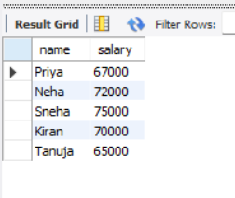
2. Find the employees who belong to the department with the highest average salary.
Solution : -
SELECT * FROM Employee WHERE department_id = (SELECT department_id FROM Employee GROUP BY department_id ORDER BY AVG(salary) DESC LIMIT 1);
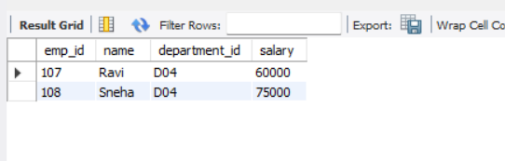
3. List all employees who have made at least one sale.
Solution : -
SELECT e.emp_id, e.name, e.department_id, e.salary FROM Employee e WHERE e.emp_id IN (SELECT emp_id FROM Sales);
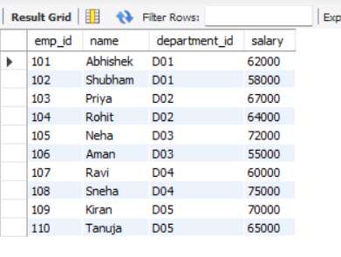

4. Find the employee with the highest sale amount.
Solution : -
SELECT e.emp_id, e.name, s.sale_amount FROM Employee e JOIN Sales s ON e.emp_id = s.emp_id WHERE s.sale_amount = (SELECT MAX(sale_amount) FROM Sales);
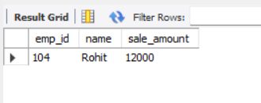
5. Retrieve the names of employees whose salaries are higher than Shubham’s salary.
Solution : -
SELECT name, salary FROM Employee WHERE salary > (SELECT salary FROM Employee WHERE name = 'Shubham');
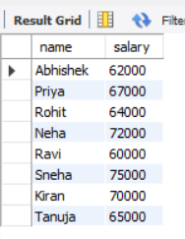
6. Find employees who work in the same department as Abhishek.
Solution : -
SELECT name, department_id FROM Employee WHERE department_id=(SELECT department_id FROM Employee WHERE name='Abhishek') AND name<>'Abhishek';
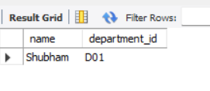
7. List departments that have at least one employee earning more than ₹60,000.
Solution : -
SELECT DISTINCT department_id FROM Employee WHERE salary > 60000;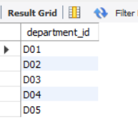
8. Find the department name of the employee who made the highest sale.
Solution : -
SELECT d.department_name FROM Department d JOIN Employee e ON d.department_id=e.department_id WHERE e.emp_id=(SELECT emp_id FROM Sales ORDER BY sale_amount DESC LIMIT 1);


9. Retrieve employees who have made sales greater than the average sale amount.
Solution : -
SELECT e.name FROM Employee e JOIN Sales s ON e.emp_id=s.emp_id WHERE s.sale_amount > (SELECT AVG(sale_amount) FROM Sales);
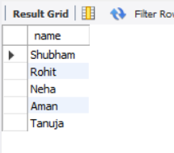
10. Find the total sales made by employees who earn more than the average salary.
Solution : -
SELECT SUM(s.sale_amount) FROM Sales s JOIN Employee e ON s.emp_id=e.emp_id WHERE e.salary > (SELECT AVG(salary) FROM Employee);


11. Find employees who have not made any sales.
Solution : -
SELECT name FROM Employee WHERE emp_id NOT IN (SELECT emp_id FROM Sales);

12. List departments where the average salary is above ₹55,000.
Solution : -
SELECT department_id FROM Employee GROUP BY department_id HAVING AVG(salary) > 55000;
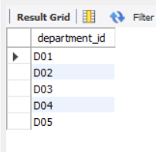
13. Retrieve department names where the total sales exceed ₹10,000.
Solution : -
SELECT d.department_name FROM Department d JOIN Employee e ON d.department_id = e.department_id JOIN Sales s ON e.emp_id = s.emp_id GROUP BY .department_name
HAVING SUM(s.sale_amount) > 10000;
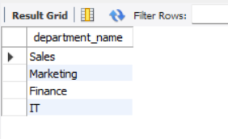
14. Find the employee who has made the second-highest sale.
Solution : -
SELECT e.name FROM Employee e JOIN Sales s ON e.emp_id = s.emp_id ORDER BY s.sale_amount DESC LIMIT 1 OFFSET 1;

15. Retrieve the names of employees whose salary is greater than the highest sale amount recorded.
Solution : -
SELECT name FROM Employee WHERE salary > (SELECT MAX(sale_amount) FROM Sales);
